**Lab 4 (a) : NMOS Parameter measurements**

**Objective:**

Understand MOSFET operation by measuring the threshold voltage (Vt) and the MOSFET transconductance parameter (k) for an n-channel MOSFET.

**Equipment and Components:**

* Breadboard, Power supply, Digital Multimeter
* NMOS transistor (2N7000)
* Resistors (1MΩ, 1kΩ)

**Background:**

In general, these precautions apply to all MOS and CMOS parts:

* The parts that you will use in this lab are easily damaged, so be careful with them.
* Use jumper wires rather than bending the leads. Don’t subject them to high voltages or static electricity.
* Static affect on them is like lightning on the human. Even sitting in a chair generates significant static charge.
* Momentarily touch any grounded metal part to discharge yourself before handling the part or touching the leads. Use of a grounding strap is desirable.
* Make sure your connections are not inverted before applying the power. The circuit may “latch up”- possibly causing permanent damage (with no smoke or heat.)
* Disconnect or turn-off the supply voltage before making changes in your circuit.For added safety, ground any unused inputs.

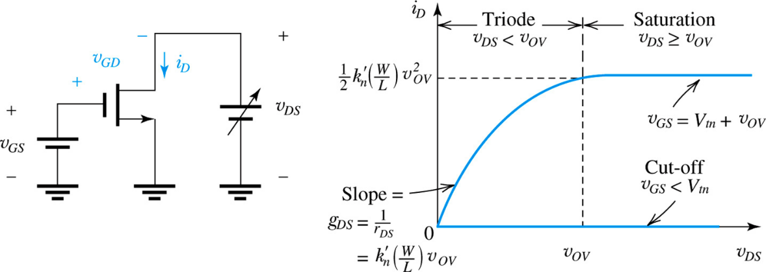

Fig. 1. Circuit for Vtn measurement

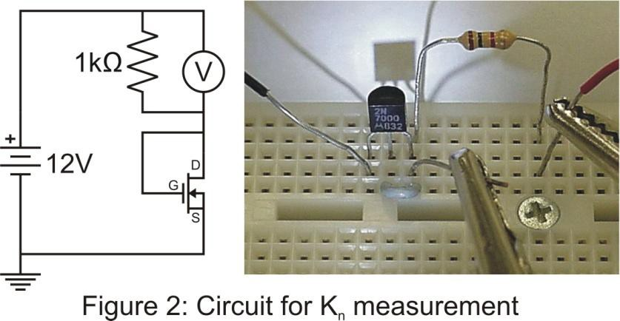



Saturation current equation:

The NMOS in Figure 2 is operating in saturation mode. However, a minimum voltage must be reached before the transistor permits current to flow. This minimum voltage is called the threshold voltage, Vt.

By adding a 1kΩ drain resistor we ensure that there is a significant amount of current flowing through the circuit, so the transistor is operating well above the threshold voltage. By measuring the voltage across and the current through the transistor in this circuit, kn can be determined by using the saturation current equation.

**Procedure:**

Part1: Measuring Vtn

**Simulate:**

1. For the circuit shown in Fig. 1, set VDS = 5V.
2. Sweep the gate voltage from 0V to 5V in increments of 0.1V.
3. Plot a curve for ID vs. VGS.
4. Note the value of VGS at which the current turns on. This is the Vtn for the particular NMOS.

**Build:**

1. Set VDS to a constant 5V.
2. Sweep VGS from 1V to 3.5V in increments of 0.25V, and measure the drain current from the power supply.

*Note:* If the power supply is not capable of measuring small values of current (in µA), add a 100Ω resistor in series to the drain end and measure the voltage drop across it to obtain the current.

1. Plot the ID vs. VGS curve on an engineering paper.
2. Note the value of VGS at which the current turns on.

Part 2: Measuring kn

**Simulate:**

1. For the circuit shown in Fig. 2, set Vin = 12V.
2. Measure the current flowing through the NMOS, iD.
3. Measure the voltage across the 1kΩ resistor.
4. Calculate the voltage drop VDS and VGS based on KVL.
5. Using Vtn value from Part 1, and saturation current equation (ignoring λ), calculate kn.

**Build:**

1. For the circuit shown in Fig. 2, set Vin = 12V.
2. Measure the voltage across the 1kΩ resistor. The remaining drop is across the NMOS.
3. Using the voltage drop across the resistor determine the current flowing through the transistor.
4. Using Vtn value from Part 1, and saturation current equation (ignoring λ), calculate kn.

**Conclusion:**

1. Summarize the simulated and measured values for Vt and Kn in a table. Explain any discrepancy.
2. Keep this transistor with you for the future NMOS labs.